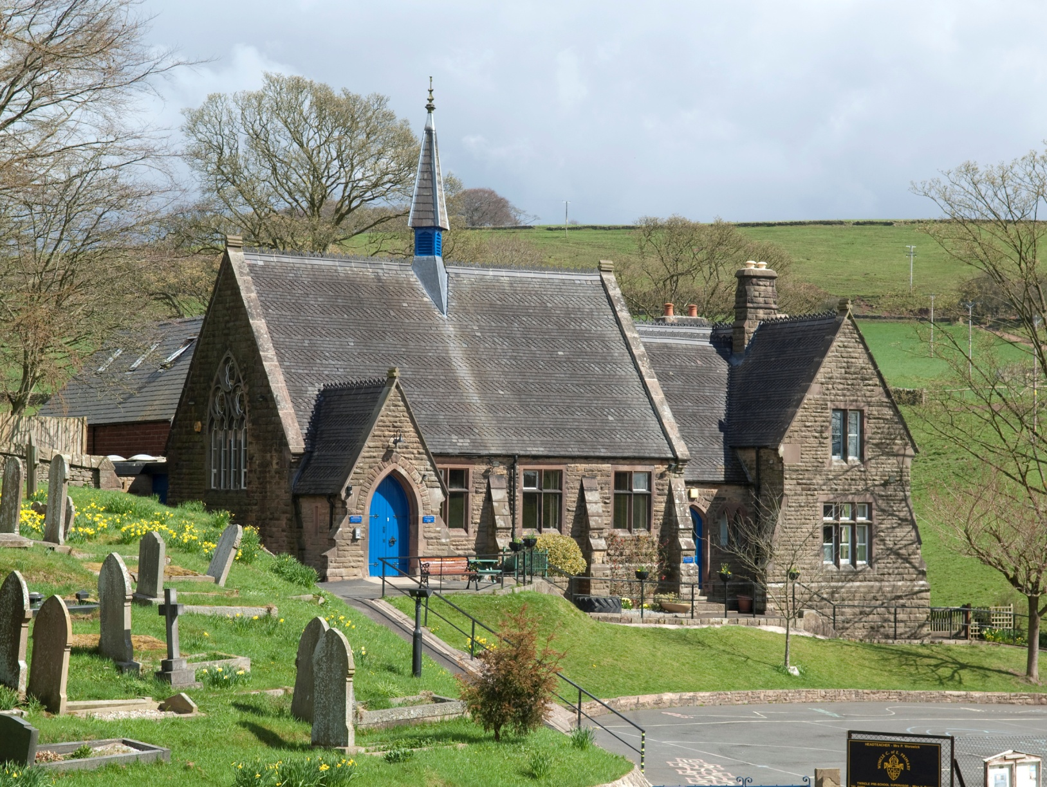

**Curriculum Policy**



Version: APPROVED

Updated: January 2025

**Wincle CE Primary School**

**Wincle**

**Macclesfield**

**Cheshire**

**SK11 0QH**

**Tel: 01260 212592**

**Headteacher: Mrs S Smith**

**Chair of Governors: Mrs S Goodwin**

**www.wincleprimaryschool.org**

**Wincle School’s Curriculum Policy**

Our school’s vision:

Wincle School provides an enriching and outstanding rural education. We nurture the whole individual: body, mind and soul, inspiring rounded, happy, courageous children **who shine in all that they say and do.** Our children exhibit a passion for learning, a confident faith, a loving concern for community and an inclusive respect for all.

We encourage our pupils to ‘Shine like Stars’ (Philippians 2:15) and to do this run with the following acronym:

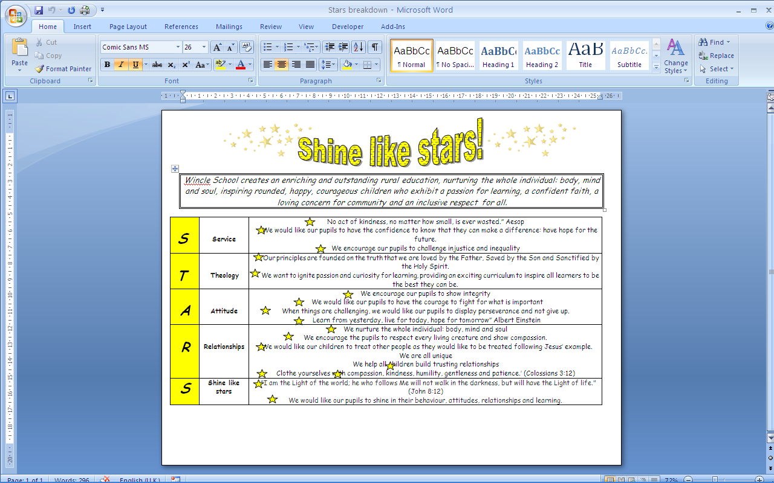

Curriculum Policy – Wincle CE Primary School

To be read in conjunction with the Curriculum Statements for each subject.

**Statement of intent:**

At Wincle CE Primary School, we respect and value all God’s children and are committed to providing a caring, friendly and safe environment for all our pupils so they can learn, in a relaxed and secure atmosphere which is supported by our Christian ethos. We believe every pupil should be able to participate in all school activities in an enjoyable and safe environment and be protected from harm. This is the responsibility of every adult employed by, or invited to deliver services at Wincle CE Primary School. We recognise our responsibility to safeguard all who access school and promote the welfare of all our pupils by protecting them from physical, sexual and emotional abuse, neglect and bullying.

At Wincle CE Primary School, our curriculum is based on the September 2014 National Curriculum for Key Stages 1 & 2 and the Early Years 2021 framework in Reception. Our rigorous, well planned curriculum combined with high quality teaching ensures that children are supported to be well rounded, empathetic young people who have a genuine thirst for learning. Children develop a strong sense of moral purpose in addition to a respect for and understanding of people.

**Introduction**

The curriculum is all the planned activities that we as a school organise in order to promote learning, personal growth and development. It includes, not only the formal requirements of the National Curriculum, but also the range of extra-curricular activities that the school organises in order to enrich the experiences of our children. It includes the ‘hidden curriculum’, or what the children learn from the way they are treated and expected to behave. We aim to teach children how to grow into positive, responsible people, who can work and co-operate with others, whilst developing knowledge, skills and good attitudes to learning, in order that they achieve their true potential. For more information, please see our Curriculum Enrichment information on the school website as well as our Cultural Awareness Pledge.

**Curriculum Drivers**

Our curriculum is planned around a series of themes called drivers, which maximise cross-curricular links whilst ensuring rigour where there is a clear development in the learning of key skills. As a school we have identified the ‘curriculum drivers’ that personalise our curriculum. These have been chosen through consultation with staff – identifying the needs and interests of the pupils at Wincle CE Primary School. They are:

*​*

**Physical, Mental and Spiritual Well-being**  
We are passionate about the health of our children. It is important to us that all members of our school community are healthy. Throughout life, our children will face many difficult challenges and need to have the mental and physical strength to be successful and happy. We want our children to lift their eyes from the screen to be excited by the real world, engaging in rich experiences to develop imagination. We will use competition to develop confidence and allow them to manage real risks by having fun and a little danger!  
Our curriculum will provide opportunities for children to learn to respect and appreciate the diversity of an ever-changing society. We aim to nurture confident, curious, independent children who are able to make responsible choices and have the ability to show empathy and compassion towards others. We believe in the power of the school community to change and enhance lives.

​

**The Environment**  
We want to enhance and enrich our children’s understanding of their local and global environment by providing opportunities for learning beyond the classroom. They need to experience the richness of its diversity and show they care about its management and sustainability. We will aim to develop an attitude of care and respect, where children understand how actions and decisions impact upon the world.

**Initiative**  
It is vital that we nurture the natural curiosity of our children, enabling them to become independent, imaginative and enterprising. We will give children opportunities to think critically, by solving problems and making choices. Our children need to develop resilience, fuelled by intrinsic motivation, to be able to deal with challenges across the curriculum and in life outside the classroom. Developing the skills to work independently and become resourceful will be key to this. We would like our children to engage and express their ideas in a variety of creative forms. We will give the children opportunities to be imaginative, to use experiences and observations to make connections in their learning and appreciate that learning can be accomplished in different forms.

​

**Communication**  
We want our children to become eloquent orators, speaking with confidence and fluency in a variety of situations. We believe that helping our children find their voice is as important as them becoming avid readers or great writers and will work to broaden vocabulary and encourage talk in all areas of learning.

**Our Christian Values**   
Our school vision is to **‘**provide an enriching and outstanding rural education. We nurture the whole individual: body, mind and soul, inspiring rounded, happy, courageous children **who shine in all that they say and do.** Our children exhibit a passion for learning, a confident faith, a loving concern for community and an inclusive respect for all.’  
We have identified five Christian values which underpin our whole ethos and curriculum. These are Respect, Hope, Compassion, Perseverance and Integrity.

**Respect:**

Respect is an important core value in our schools because it is the foundation stone of relationships within our school and wider community. In our community, we learn that God made us all different and unique. This is something that we celebrate together. We learn to value ourselves, each other and the wider community through honesty, tolerance and trust, where everyone has an equal right to our care, time and attention as a reflection of God’s love. This means valuing differences and showing tolerance. The ‘golden rule’ is:   
*‘Treat others as you would want them to treat you’*Matthew 7:12

**Hope:**

At Wincle, we have high hopes and aspirations for our future, our school and community. We also understand that faith gives us hope for both now and for the future, and that this hope brings confidence. At Wincle, we develop our value of hope through: never giving up on our pupils; wanting the best for them academically and in their character; helping them see light despite the darkness; investing in our families; and learning about prayer.

**Compassion:**

Compassion is caring about someone else’s feelings and trying our best to understand how others might be feeling, and offering to help that person. We can show that we are kind and caring by doing acts of kindness for anyone, friends, family or even people we don’t know. We show ‘Random acts of kindness’. We donate to charities. We try to be kind to everyone even if we are not friends or we don’t always get along. We aim to follow the example of Jesus and treat others as we would wish to be treated

*Finally, all of you, live in harmony with one another; be sympathetic, love as brothers, be compassionate and humble.*1 Peter 3:8

We try to put ourselves in others’ shoes and think about how they might be feeling. We talk to people about how they are feeling if they want to and we pray for those who need it.

**Integrity:**

The word integrity comes from the same Latin root as integer and implies a wholeness of person. Just as we would talk about a whole number, so also we can talk about a whole person who is undivided. A person of integrity is living rightly, not divided, nor being a different person in different circumstances. A person of integrity is the same person in private that he or she is in public. Our pupils are encouraged and supported to act with integrity in all situations.

**Perseverance:**

Perseverance is persistence in doing something despite difficulty or delay in achieving success.  It is persistence, tenacity, determination, resolve, resolution, resoluteness, staying power, purposefulness and firmness of purpose.

At Wincle Primary School, we strive to make our children passionate for learning and make their learning as much fun and as meaningful and relevant as possible. We offer children an excellent education in a safe, calm, creative, inclusive and stimulating environment. Every child is valued as an individual; we aim to nurture well rounded, respectful and confident children who will develop skills for life-long learning. We nurture our children on their journey and encourage them to be creative, unique, open-minded and independent individuals, respectful of themselves and of others in our school, our local community and the wider world.

We take our responsibility to prepare children for life in modern Britain very seriously and ensure that the fundamental British Values are introduced, discussed and lived out through the ethos and work of our school.

Our curriculum promotes respect for the views of each individual child, as well as for people of all cultures. We value the spiritual and moral development of each person, as well as their intellectual and physical growth. We organise our curriculum so that we promote co-operation and understanding between all members of our community.

We are fortunate at Wincle to have a spacious learning environment of which includes an outdoor classroom, improved EYFS area, gardening beds and a pond. This environment is respected and used by all in school and we aim, through our curriculum, to teach respect for our world, and how we should care for it for future generations, as well as our own. At Wincle, our values permeate all areas of school life and are reflected by the school’s simple motto: Shine Like Stars.

**Aims**

At Wincle Primary School, we aim to offer a balanced and broad curriculum which enables all pupils to:

* Enjoy learning
* Feel successful in their learning and to promote high self-esteem
* Become creative, independent learners
* Be given significant time to learn new skills and have time to practise those skills
* Have the flexibility to decide how best to learn in different situations
* Have the flexibility to decide what they are going to learn and how
* Be given the opportunity to decide upon the final outcome of their learning
* Be able to set own targets for learning
* Know what their strengths are and which areas they need to develop
* Become successful lifelong learners who are able to reach their full potential
* Be able to evaluate and assess their own learning
* Develop their critical thinking
* Understand and value the importance of truth, fairness, right and wrong
* Nurture positive relationships promoting working co-operatively with one another
* Help children understand Britain’s cultural heritage
* Explore their spiritual, moral, cultural, mental and physical development
* Learn and practise the basic skills of English, Mathematics and Computing
* Makes learning more meaningful by putting it into context
* Challenge themselves and engage themselves in deeper learning

**Organisation and Planning**

At Wincle CE Primary School, our curriculum is based on the September 2014 National Curriculum for Key Stages 1 & 2 and the Early Years 2021 framework in Reception.

Our curriculum is delivered using a variety of approaches and resources depending on the nature of the subject being taught and the needs of the children (for more details please refer to the separate subject areas of our school website).

The Reception/KS1 curriculum is planned on a two-year cycle linking the Prime and Specific Areas of Learning in the EYFS with the early objectives of the National Curriculum, and is guided by the children’s interests. In KS2, our curriculum is all planned on a two/three yearly cycle with an emphasis placed on ‘wow’ experiences, cross curricular links and learning supported by quality texts and other quality experiences.

Although teaching and learning is still theme-led, each subject’s learning journey is carefully planned from the EYFS up to Year 6 and has a subject progression grid to show this over view clearly.

All teachers are responsible for planning, evaluating and teaching in their classes. The National Curriculum stipulates the expectations which form the long-term plans and subject progression grids from which the teachers produce long term plans to identify key concepts, knowledge and vocabulary to be taught in a specific subject unit.

The more detailed weekly/fortnightly short-term planning will focus on the teaching and learning processes and styles. Class teachers meet regularly to ensure continuity of provision and moderation in terms of expectations and outcomes across the year groups. Short term plans outline the individual lessons and adaptations made for individual classes and children along with assessment opportunities and expected outcomes. Particular attention is given to clear and appropriate differentiation, progression and attainment at this point in the planning process.

At Wincle CE Primary School, we use the National Curriculum 2014 as a starting point for all long-term plans. This, in conjunction with subject association resources and some materials from the Essentials curriculum written by Chris Quigley supports us to ensure clear learning intentions and progression across the year groups. Curriculum coverage is mapped annually against long term plans to ensure there are no gaps in our curriculum.

**Learning Environment**

Our learning environments are used as teaching tools. As a school, we keep them organised and for the most part, make key knowledge and vocabulary accessible so that children can locate and use this key information easily and efficiently. This can do done by signposting or using neutral backgrounds and selecting and organising display carefully. Overcrowded and ‘busy’ displays are discouraged. In the EYFS, displays and resources are organised and labelled to enable learning and teach children organisational and ordering skills. Displays around school are also used to showcase, value and celebrate children’s achievements and great work. Children have input into these displays and the aim of them is to promote children’s self-esteem and recognise good learning.

**Assessment, Recording, Monitoring and Evaluation**

Short and medium-term assessment is the responsibility of the class teacher and is in line with the assessment policy. However, teachers will use informal assessment and observation on a daily basis to determine what children can do independently and therefore plan next steps for learning.

Formative assessments take many different forms and are reflected in the pupil’s books/work in the detailed marking and provision of constructive feedback (not every piece of work is marked in depth). Feedback follows the school’s policy and identifies areas for children to improve giving focused challenges and expecting children to take ownership of their learning and respond and reflect in order to improve.

Summative assessments support teacher assessments in the core subjects and children are presented with these in a relaxed format so as to cause minimal anxiety for pupils. These are used to help prepare children though the year groups for the end of key stage testing as required by law. Reception pupils are assessed using the Foundation Stage Profile. Pupil profiles in Tapestry are established for each child in Reception and assessments are made against the Foundation Stage Profile Statements.

Children’s progress and attainment in each subject will be assessed by their teacher against the learning outcomes and end of year expectations. Pupil progress will be reported to parents at the end of each term either in writing or at an appointment where parents are invited to discuss their child’s progress.

**The roles of the Curriculum Leader**

It is the role of the curriculum leader to keep up to date with developments in all subjects, at both national and local level. They lead staff to work as a team to review the way each subject is taught in the school and plan for improvement. This development planning links to whole-school objectives. Each review will ensure that there is full coverage of the National Curriculum and that progression is planned into schemes of work.

Due to our small school nature, the teaching team work as one leading all subjects. Each term, we review, audit and evaluate a chosen subject and devise an action plan. We aim to complete reviews of all subjects within a two year cycle.

A subject review consists of many elements:   
• staff supporting and offering advice to colleagues on issues related to the subject;   
• support staff development and improve the quality of teaching and learning over time;   
• monitor pupil progress in that subject area by working alongside colleagues, book looks, pupil interviews, lesson observations and planning scrutiny;   
• monitor and evaluate teacher’s planning and teaching;   
• ensure all staff are kept up to date with developments in the subject by relevant reading;  
• liaise with appropriate bodies e.g. other schools, governors, the LEA etc. about matters relating to their subjects   
• provide efficient resource management for the subject.   
• map coverage of the curriculum to long term plans

**Risk Assessment**

Whilst planning for the curriculum, teachers will give consideration to any relevant risks. If appropriate, these will be highlighted on planning and the appropriate documents completed to meet with health and safety regulations. Where water is involved in a risk assessment (for example river fieldwork as a part of geography) the LA will be notified and permission sought through Evolve as part of the risk assessment.

**Inclusion and Differentiation**

In order to provide all pupils with relevant and appropriate work at each stage:   
• We set high expectations and suitable learning challenges  
• Respond to pupils’ diverse needs making reasonable adjustments where appropriate, or offer additional support and intervention  
• Endeavour to overcome all potential barriers to learning

Learning is planned and adapted to enable children to broaden, deepen and accelerate their understanding and development of skills and knowledge. Children are challenged to think at depth and deepen their learning across the curriculum. Regular formative assessments identify children/groups of children for differentiated activities. Our curriculum is inclusive and promotes a growth mind set in all our children linking back to our school moto – Shine Like Stars.

**Curriculum communication to parents**

Communication with our parents’ about how their children are performing and what they are experiencing in school is a high priority to us and we do this in a number of ways.   
• Formal reporting to parents three times a year either in the form of a written report or a parent consultation evening where parents’ make an appointment to meet with their children’s teachers and discuss their progress.   
• School website and year group pages inform parents what has been happening in the wider curriculum.   
• The school’s Facebook page informs parents instantly of whole school or enhanced activities which are taking place.

Teachers are of course also available at the start and end of each day for any necessary communications. Teachers regularly use email to communicate with parents and the school office is another port of call.

**Enhanced Provision**

We aim to enrich our pupils’ lives by offering a variety of non-statutory extra-curricular experiences (clubs, visits, visiting speakers, sporting events etc). In addition, we seek to enhance our pupils’ learning through developing positive two-way relationships with our local community. As part of our enhanced provision, each year we have a team of school leaders (School Games Crew, Ethos Committee members, Eco Warriers, Head Boy/Head Girl, Healthy School Committee members…). These are really important roles and give our children the opportunity to apply for and commit to a role for the year. In doing this. they develop a number of the learning behaviours which we place so much importance on children acquiring in their time at Wincle. By giving our children these opportunities, we are equipping them with life skills and ambition.

**Accountability and responsibility**

Our governing body is responsible for monitoring the way the school curriculum is implemented.